Delta4 for DQA

# Purpose

This procedure explains how to use the Delta4 software on the Delta4 computer to collect and analyze dose delivery information. It is meant for use in the Tomo and Elekta DQA procedures.

For DQA troubleshooting tips, see DQA Troubleshooting.

# Collecting Dose

1. Open the DQA plan in Delta4.
   1. Double-click the Delta4 icon on the desktop of the Delta4 computer.

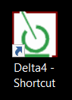

* 1. Log in with username admin and blank password.

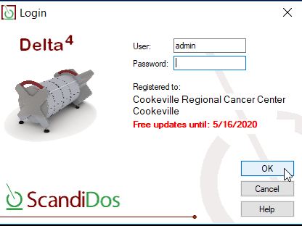

* 1. If Delta4 is set to use a temperature correction, you should be prompted for the temperature. (If this takes a minute, do not be alarmed.) Enter the temperature that you measured on the phantom.

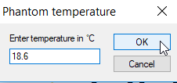

* 1. Click the folder in the top left corner and search the patient’s name.

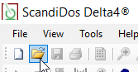

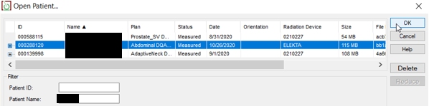

* If the patient exists in the database:
  1. Select the patient’s name and click **OK**.
  2. Go to **Edit** > **Add Measurement Plan**. Even if you are reshooting a plan (e.g., on a different machine), you should still **Add Measurement Plan**instead of **Add Measurement Course** as the latter automatically applies the phantom shifts from the plan that was last shot.
* If the patient does not exist:
  1. Click the piece of paper in the top left corner to create a new patient.

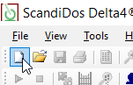

* 1. Click the browse button and navigate to the folder containing the DQA plan.

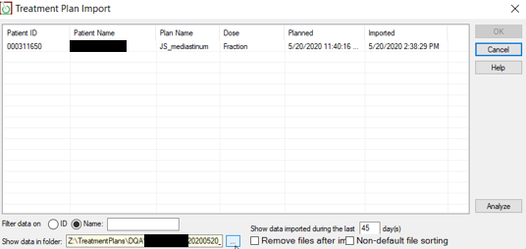

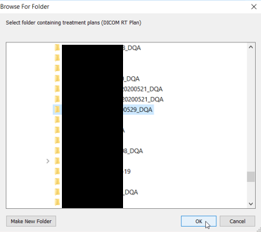

* 1. Select the plan and click OK.

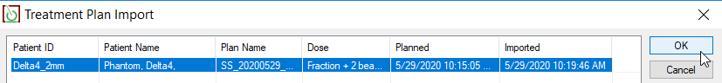

1. Shoot a beam.
   1. Select the beam.

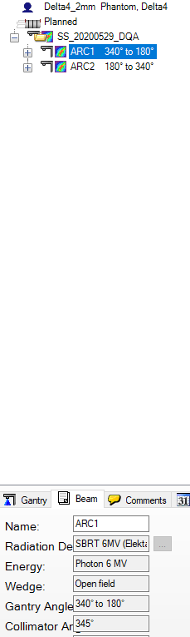



* 1. Click **Start**. Then shoot the field on the machine.
  2. When the beam finishes, click **Stop**.

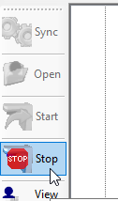

# Analyzing Dose

In accordance with TG-218, CRMC uses gamma pass rate as our pass/fail criterion with 95% gamma pass rate, 3% dose deviation, and 2 mm DTA tolerance, and 90% gamma pass rate action level. The beam is green is it passes, red if it fails (is out of tolerance). If the overall plan passes, individual beam failures are usually a non-issue.

**Example:** Both beams pass.

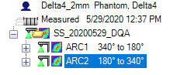

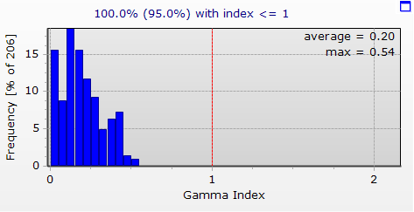

100% ≥ 95%, so plan passes

1. Write down the initial dose deviation, DTA, and gamma pass rates, as well as the gamma average.
2. Rescale planned dose.
   1. Calculate the scale factor to four decimal places.

* For Tomo:
  1. Open the latest Tomo TG-51 calibration spreadsheet.
  2. Divide the measured output by the expected output.



Example: 901.728 / 881 ≈ 1.0235

* For Elekta:
  1. In Suncheck, click **Home**.



* 1. Click today’s approved daily QA for the appropriate machine.

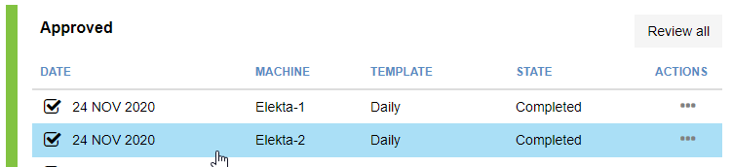

* 1. For the appropriate energy (6MV in this example), divide the measured output by the expected output.

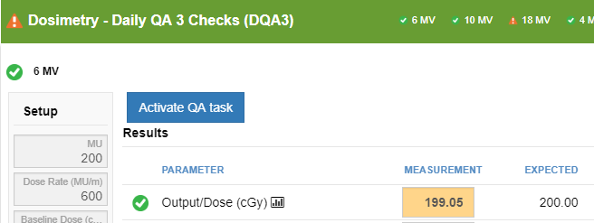

Example: 199.05 / 200 ≈ 0.9953

* 1. Write down the scale factor.
  2. With the plan selected, go to **Edit** > **Rescale Planned Dose…**

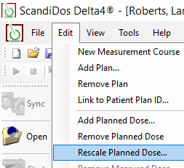

* 1. Enter the scale factor in the **Factor** field and click **OK**.

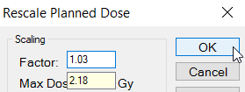

* 1. Write down the new dose deviation, DTA, and gamma pass rates, as well as the gamma average.

1. Optimize phantom position.
   1. Highlight the plan and go to **Edit** > **Optimize phantom position**.

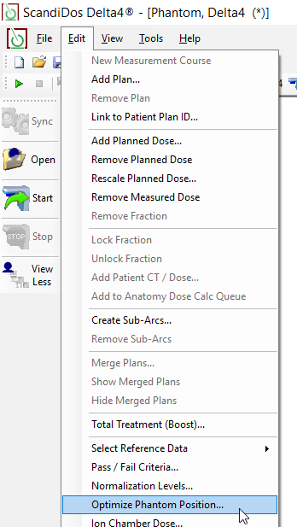

* 1. Wait until you see “Ready.” Shifts should be within tolerance according to DTA criterion of 3 mm. (Shifts are generally greater on Tomo than on Elekta.) Write down the initial and optimized X, Y, and Z offsets. Click **Accept New Off**.

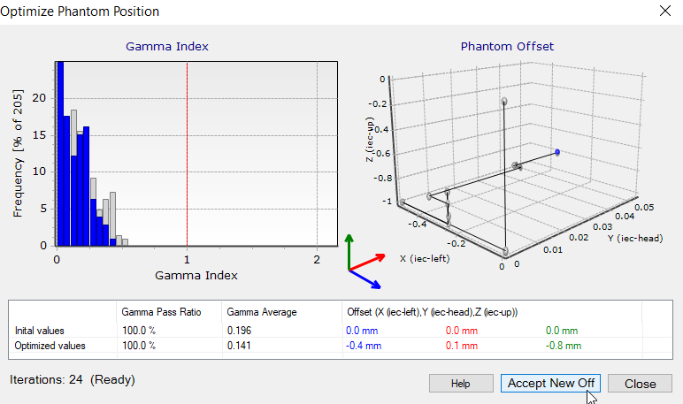

* 1. Write down the new dose deviation, DTA, and gamma pass rates, as well as the gamma average.

1. If plan is still at action level even after rescale and optimization, ensure that both fraction and beam dose are normalized to max dose (“Edited Value”), not isocenter.

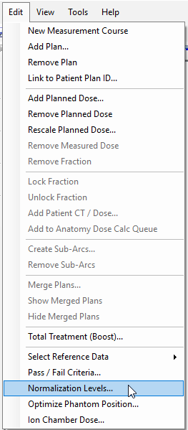 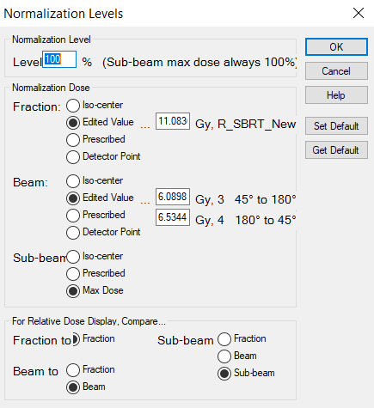

1. If the plan is still below 95%, change the DTA pass criterion to 2 mm.

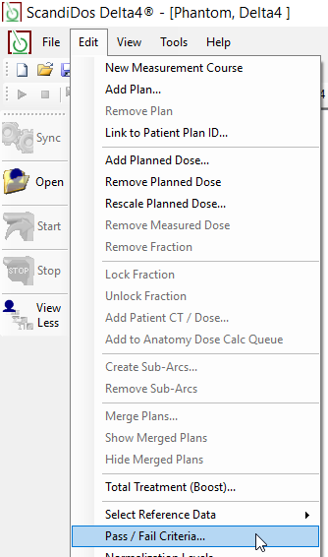 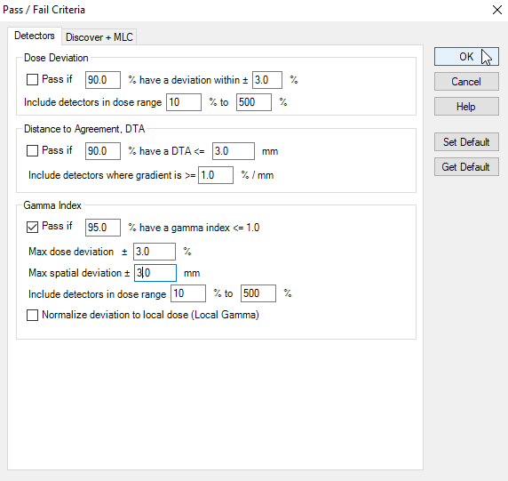

1. If the plan is still at action level, inform a physicist. They will likely suggest changing the pass/fail criteria. Estimate the criteria that will enable a pass by examining the **Gamma Evaluation** for the overall plan and individual beams.
   1. For each the overall plan and each beam, right-click the gamma histogram and select **Gamma Evaluation**.

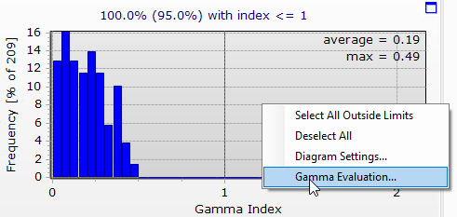

* 1. Find the most stringent distance deviation and DTA that enable a pass, such that the dose deviation ≥3% and the DTA ≥2 mm.

**Beam 1:**

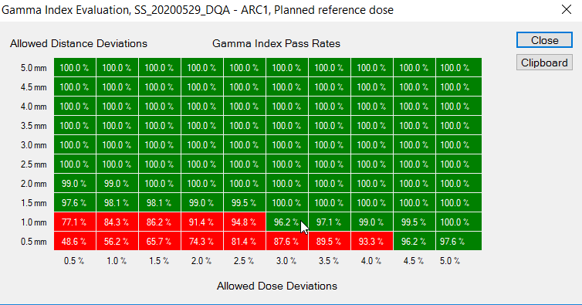

**Beam 2:**

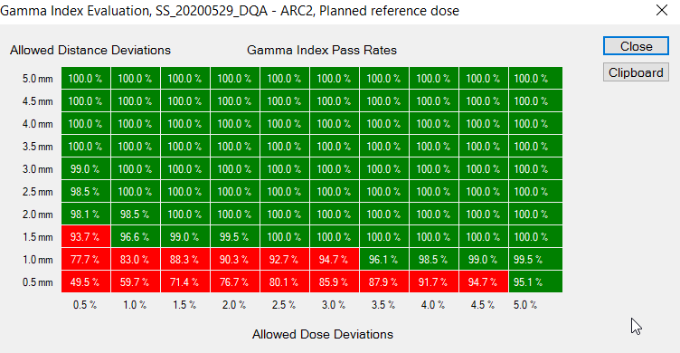

* 1. If the determined deviations are acceptable, change the pass/fail criteria. Note that the dose difference and DTA must be changed in addition to gamma, in order to update all graphs.



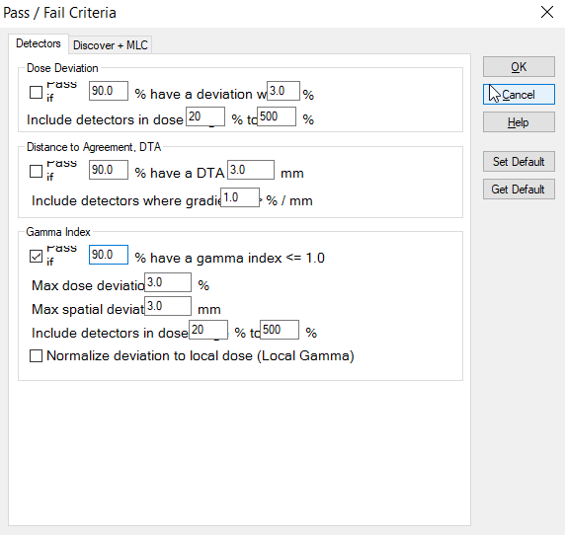

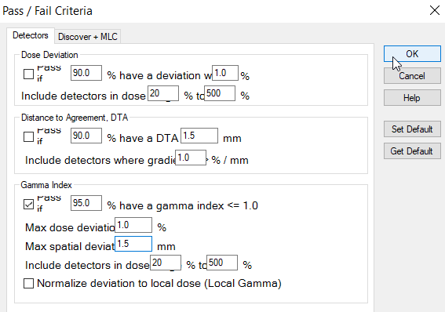

# Printing a Report

1. After you rescale the dose, the Comments should auto-populate (but occasionally do not):

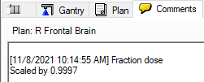

Add the MD initials and the machine name.

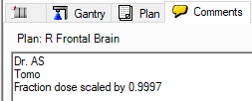

1. Change the dose display.
   1. Change the display from **Abs. dose** to **Rel. dose**.

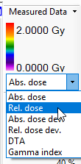

* 1. Turn off **Automatic Scale**.

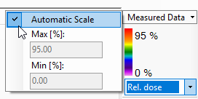

* 1. Change **Max [%]** to 110 for non-SBRT and 125 for SBRT.

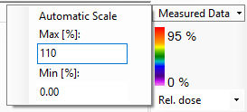

1. Add dose profiles.
   1. On the first plane on the 2D Planes tab, right-click in the area of max dose and select **Vertical Profile**.

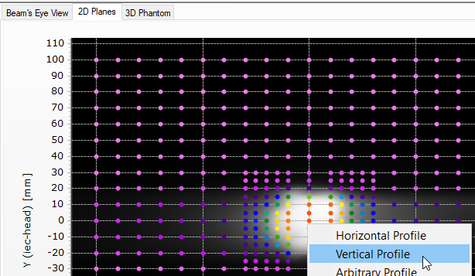

* 1. On the second plane, add a **Horizontal Profile**.

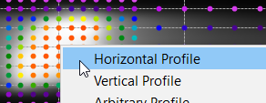

1. Save the patient using the save icon in the top left corner.

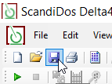

1. Print the Physics Report.
   1. Click the print icon in the top left corner.

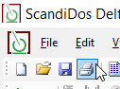

* 1. Change the name of the document to the plan name. If this is an Elekta plan, also include the machine name in parentheses.
* For a Tomo plan:

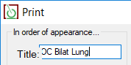

* For an Elekta plan:

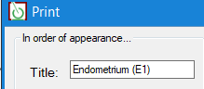

* 1. Use the following other print settings. These should be saved from last time.

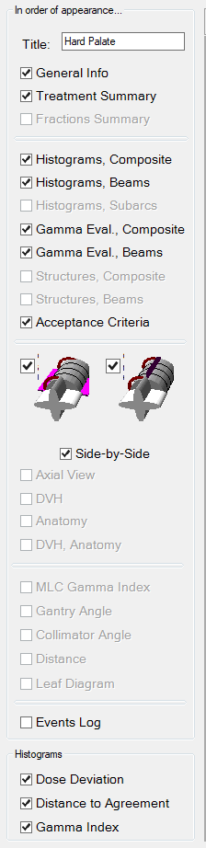

Click **OK**.

* 1. Save the document in **Z:\TreatmentPlans\DQA Reports** as <plan name> DQA for a Tomo plan, or <plan name> DQA (<machine name>) for an Elekta plan.
* For a Tomo plan:

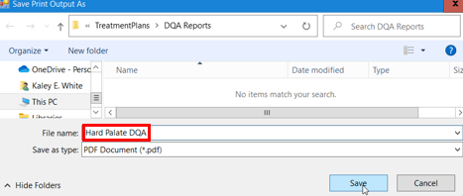

* For an Elekta plan:

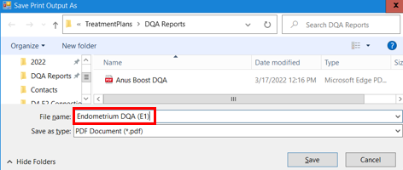

1. Add the data you wrote down, to the DQA statistical analysis spreadsheet.